“MyProperty”

Software Requirement
and
Software Design
Document

---------------------------------------------------------------------------------------------------------------------
Atul Shimpi, Pune, India,
01, May, 2015, 14:06
Index
Introduction 3
Software Requirements 3
Users 3
Admin 3
Agent 4
Customer 4
Functionality 4
Agent Registration 4
Sell/Rent Property 4
Send/View Messages 5
Search Properties 5
UI Layouts 5
Application Header 5
Application Footer 5
Index/Home Page 5
Admin Home Page 6
Agent Home Page 6
Customer Home Page 6
Registration Page 6
Sell/Rent Property UI 7
Software Designing 8
Class Diagram 8
Database 8
Technical Details 8
Performance 8
Testing 8
Security 8

Introduction
This document describes the Software Requirement and Software Designing for “MyProperty” web application. “MyProperty” shall be a web application where users can post their property to be sold or rented and other users can search for properties to be rented or sold.

Software Requirements

Users
The application shall have 3 types of users

Admin
Admin shall be able to administrator the application. He will have access to whole application.
He shall be able do below operations
- Login/Logout of the application
- Agents and Customers shall register themselves in the application. When they register, their registration shall be Approved/Rejected/ by the admin. Approval/Rejection notification shall be send to the Agent/Customer by email.
- When the user logs in the application he shall be able view all the customers and agents details who have send request for approving registration.
- Admin shall be able to post property for selling
- Admin shall be able to search property
- Shall be able to view/add/edit users
- He shall be able to view/print/export to PDF format below reports
  - List all agents
  - List all customers
  - List/Search all properties by Type/Agent/Area/City/Keyword/Value/PurchaseType
- He shall be able to send/view messages to Agents/Customers

Agent
Agent shall be able to do below operations
- Register himself
- Login to application and post properties for selling/renting/sharing
- Logout
- He shall be able to send/view messages to Agents/Customers
- View all the properties posted by him

Customer
Customer shall be able to do below operation
- Register himself
- Login/Logout
- He shall be able to send/view messages to Agents
- List/Search all properties by Type/Agent/Area/City/Keyword/Value/PurchaseType
- Shall be able to send interest in property to the agent via email

Functionality

Agent Registration
Agent shall provide below information for registration
Role : User can select below roles
- Agent
- Customer
Personal Information
- First Name
- Last Name
Address
- Address Line 1
- Address Line 2
- City
Contact Details
- Email Id
- Landline
- Mobile No

Sell/Rent Property
Agent shall be able to post properties for selling/renting
He shall provide below information for property
- Type : Residential/Commercial etc
- Purchase Type : Sell/Rent
- Area in Square Feets
- Address Line 1
- Address Line 2
- City
- Rate/Rent
- Comments

Send/View Messages
Agent/Customer shall be able to send/view messages to customers.
He shall be able select a customer and view all the message communication with him.
The messages displayed shall be in order of communication i.e first message on top and last message in the bottom

Search Properties
Admin shall be able to search properties based on below criteria
- Type
- Agent
- Area
- City
- Keyword
- Value
- Purchase Type

Customer shall be able to search properties based on below criteria
- Type
- Area
- City
- Keyword
- Value
- Purchase Type

UI Layouts

Application Header
Apart from login page each page should have below components
- Application Name in the top margin
- Name of the user who is logged in
- Logout link

Application Footer
Apart from login page each page should have copyright information at the bottom of the page

Index/Home Page
This page shall be displayed when user navigates to “MyProperties” application.
This page shall have below controls

 | Control Name/HTML Tag | Properties | Purpose
1 | Label | Caption : User Name
2 | Edit Box |  | User shall enter his email id in this edit box
3 | Label | Caption : Password
4 | Edit box |  | User shall enter his password in this edit box
5 | Button | Caption : Login | After entering email id and password, user shall click this button to login
6 | Link | Caption : Register | User shall click this link to register himself

Admin Home Page
When admin logs in below menus should be displayed
- Dashboard
- Users
- Sell/Rent
- Search
- Reports
- Others
The admin should be taken to admin Dashboard page

Agent Home Page
When agent logs in no menus should be displayed. He should be taken to “Sell/Rent” page

Customer Home Page
When a customer logs in no menu should be displayed. Customer should be taken to “Search”

If a user is both – “Agent” and “Customer” then below menus should be displayed
- Sell/Rent
- Search
He should be taken to “Search” page

Registration Page
 | Control Name/Html Tag | Properties | Purpose
1 | Check Box | Caption : I want to sell/rent property | User shall select this if he want to sell property
2 | Check Box | Caption : I want to buy/rent property | User shall select this if he want to sell/rent property
3 | Heading | Caption : Personal Information
4 | Label | Caption : First Name
5 | Edit Box |  | User shall enter his first name here
6 | Label | Caption : Last Name
7 | Edit Box |  | User shall enter his last name here
8 | Heading | Caption : Address
9 | Label | Caption : Address Line 1
10 | Edit Box |  | User shall enter Address Line 1 here
11 | Label | Caption : Address Line 2
12 | Edit Box |  | User shall enter Address Line 2 here
13 | Label | Caption : City
14 | Combo box |  | User shall select city here
15 | Heading | Caption : Contact Details
16 | Label | Caption : Email Id
17 | Edit Box |  | User shall enter email id here
18 | Label | Caption : Mobile No
19 | Edit Box |  | User shall enter his mobile number here
20 | Label | Caption : Landline No
21 | Edit Box |  | User shall enter landline number here
22 | Link | Caption : Cancel | User shall click this link to cancel his registration. He shall be taken back to login page
23 | Button | Caption : Create Account | After entering all the information, user shall click this button to register himself.

Sell/Rent Property UI
The agent shall use ui to post property he wished to sell/rent
This ui shall have below controls/fields

 | Control Name/HTML Tag | Properties | Purpose
1 | Label | Caption : Property Type
2 | Combo box |  | User shall select property type from here
3 | Label | Caption : Built up Area
4 | Edit box |  | User shall enter build up area here
5 | Label | Caption : sq. fts
6 | Label | Caption : Saleable Area
7 | Edit box |  | User shall enter saleable area here
8 | Label | Caption : sq. fts
9 | Label | Caption : Address Line 1
10 | Edit Box |  | User shall enter address line 1 here
11 | Label | Caption : Address Line 2
12 | Edit Box |  | User shall enter address line 2 here
13 | Label | Caption : Area
14 | Combo box |  | User shall select area from here
15 | Label | Caption : Rate (per sq ft)/Price
16 | Edit box |  | User shall enter rent or property price here

Software Designing

Class Diagram
Class diagram for exporting reports in PDF format.
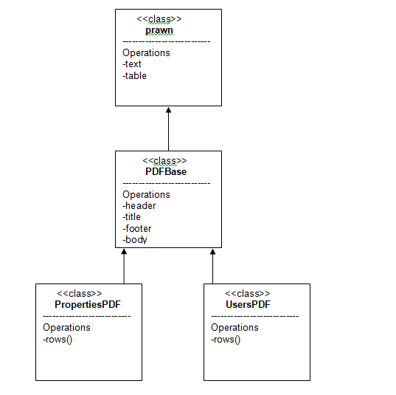

Database
MySql database is used. Below is the database schema for the application.

Technical Details
Below are the various tools/applications used for developing the application and supported by the system.

 | Component | Tool
1 | Language | Ruby 2.1.6
2 | Web Application Framework | Rails 4.2.2
3 | Database | MySql > 5.5
4 | Platform | Windows 7 (32,64), Ubuntu > 12.2 (32, 64)

Performance
TBD

Testing
TBD

Security
The Site Should be prevented against
- -Cross Site Forgery Request
- -Brut Force Password

